This Photo by Unknown Author is licensed under CC BY-SA-NC
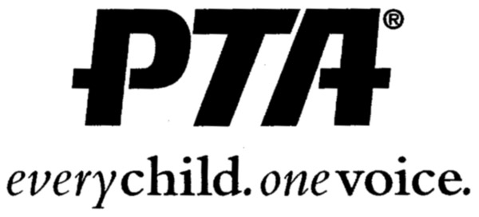
Gym Dogs

Boys Night OUT!
Who: For Boys in 1st-5th grade
When: Friday, November 9th
Where: Lakeside Elementary School
Time: 6:00-8:00 PM (please pick up promptly at 8pm)
Cost: Registration is $15.00 & $10.00 for siblings

Join us for a night of fun….
Football, gaga ball, relay races, kick ball, dodge ball, snacks, hair chalk, and much more. Gym Dogs is limited to the first 125 boys. Registration forms must be returned by Tuesday, November 6th to your child’s teacher. NO LATE registrations will be accepted.

Any questions please contact Tammy Reiprich @ treiprich@live.com or 570-877-7950 or Ashley Gager @ agagera@yahoo.com or 570-493-1521
---------------------------------------------------------------------

PTA’s Gym Dogs Registration Form
Please make all checks payable to: Honesdale PTA.
All payments must be sent in an envelope marked “Gym Dogs.” Please indicate your whole family on one sheet.
Student’s Name: __________________________________ Grade: _______
Sibling’s Name: __________________________________ Grade: _______
Parent’s Name: _______________________ Phone # __________________

Cell #: _________________________________________

Allergies: ____________________________________________________
Emergency Contact: ________________________ Phone #: ____________

I am able to volunteer for Gym Dogs: YES_________ NO _________

